**Real Estate Management System**

**Abstract**

The real estate industry is undergoing a significant transformation with the advent of advanced technology. In this abstract, we present a comprehensive overview of a Real Estate Management System (REMS) designed to streamline processes, enhance efficiency, and promote transparency in the management of real estate assets.

REMS is a digital platform equipped with robust features to cater to the diverse needs of property owners, tenants, and real estate professionals. It offers functionalities such as property listing and search, lease management, financial tracking, maintenance scheduling, and reporting capabilities.

In conclusion, REMS represents a paradigm shift in real estate management, offering a holistic solution to streamline operations, enhance efficiency, and promote transparency. By leveraging advanced technology and innovative features, REMS empowers stakeholders to maximize the value of their real estate assets in an increasingly competitive market landscape.

**Introduction to Real Estate Management System**

In today's dynamic and ever-evolving real estate market, efficient management and streamlined operations are crucial for property owners, managers, investors, and tenants alike. A Real Estate Management System (REMS) serves as an indispensable tool in this regard, providing a comprehensive platform to manage various aspects of real estate operations seamlessly.

A Real Estate Management System integrates various functionalities into a single, cohesive platform to support the end-to-end management of properties. This includes residential, commercial, and industrial real estate. The primary goal of a REMS is to enhance productivity, improve accuracy, and ensure the smooth execution of tasks related to property management.

The adoption of a Real Estate Management System can lead to significant benefits, including:

* **Increased Efficiency**: Automation of routine tasks reduces manual efforts and errors, freeing up time for strategic activities.
* **Enhanced Visibility**: Real-time access to data and comprehensive dashboards provide better visibility into operations and performance.
* **Improved Tenant Satisfaction**: Streamlined processes and responsive management improve the tenant experience, leading to higher retention rates.
* **Cost Savings**: Optimized maintenance schedules, efficient resource allocation, and better financial management contribute to cost reductions.

In conclusion, a Real Estate Management System is a critical asset for modern real estate operations, offering a robust framework to manage properties efficiently, ensure compliance, and drive profitability. As technology continues to advance, the capabilities of REMS will further evolve, enabling real estate professionals to meet the challenges of the market with agility and precision.

### Functional Requirements for a Real Estate Management System

Functional Requirements for Real Estate Management System:

1. **Property Management:**
   * The system should allow users to add, update, view, and delete property information.
   * Users should be able to search for properties based on various criteria such as address, type, price range, and square footage.
   * Property details should include attributes like address, type, bedrooms, bathrooms, price, and square footage.
   * Each property should have a unique Property ID as a primary key.
2. **Agent Management:**
   * Users should be able to manage agent information, including adding, updating, viewing, and deleting agents.
   * Agent details should include name, contact information, commission percentage, and license number.
   * Each agent should have a unique Agent ID as a primary key.
3. **Buyer and Seller Management:**
   * The system should support the management of buyers and sellers, allowing users to add, update, view, and delete their information.
   * Buyer and seller details should include name and contact information.
   * Each buyer should have a unique Buyer ID, and each seller should have a unique Seller ID as primary keys.
4. **Listing Management:**
   * Users should be able to create property listings, specifying the agent responsible, property details, date listed, and status.
   * Listings should support linking to the respective agent and property using foreign keys.
   * The system should provide functionality to update and delete listings.
5. **Contract Management:**
   * The system should enable users to create contracts documenting agreements between buyers and sellers.
   * Contracts should capture buyer and seller details, signing date, and contract status.
   * Each contract should have a unique Contract ID, and foreign keys should link to the corresponding buyer and seller.
6. **Mortgage Management:**
   * Users should be able to record mortgage details, including the buyer, lender, loan amount, interest rate, and term.
   * Each mortgage should have a unique Mortgage ID, and foreign keys should link to the respective buyer.
7. **Inspection Management:**
   * The system should support tracking property inspections, including inspection date, description of findings, and linking to the inspected property.
   * Each inspection should have a unique Inspection ID, and foreign keys should link to the inspected property.
8. **Neighborhood Management:**
   * Users should be able to manage neighborhood information, including name, location, and crime rate statistics.
   * Each neighborhood should have a unique Neighborhood ID as a primary key.
9. **Report Generation:**
   * The system should generate reports summarizing inspection findings, including inspector details, inspection date, and description of findings.
   * Reports should be accessible based on specific criteria such as inspector ID or inspection date range.
10. **Data Integrity and Security:**
    * The system should enforce data integrity constraints to ensure the accuracy and consistency of stored information.
    * Access to sensitive data should be restricted based on user roles and permissions to maintain security and privacy.

These functional requirements aim to provide comprehensive functionality for managing real estate assets, transactions, and related information within the system.

ER DIAGRAM:

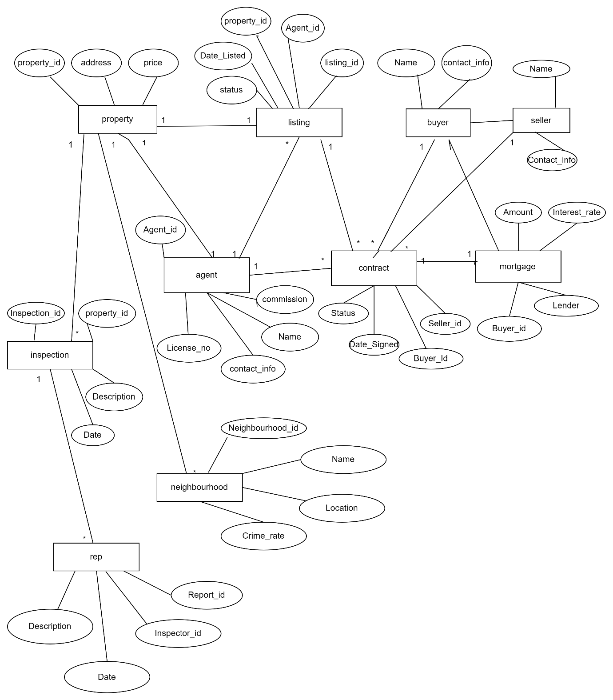

**QUERIES TO CREATE TABLES IN THE DATABASE:**

CREATE TABLE Property (

Property_ID INT PRIMARY KEY,

Address VARCHAR(255),

Type VARCHAR(50),

Bedrooms INT,

Bathrooms INT,

Price DECIMAL(15, 2),

Square_footage INT

);

CREATE TABLE Agent (

Agent_ID INT PRIMARY KEY,

Name VARCHAR(100),

Contact_info VARCHAR(255),

Commission DECIMAL(10, 2),

License_No VARCHAR(50)

);

CREATE TABLE Buyer (

Buyer_ID INT PRIMARY KEY,

Name VARCHAR(100),

Contact_info VARCHAR(255)

);

CREATE TABLE Seller (

Seller_ID INT PRIMARY KEY,

Name VARCHAR(100),

Contact_info VARCHAR(255)

);

CREATE TABLE Listing (

Listing_ID INT PRIMARY KEY,

Agent_ID INT,

Property_ID INT,

Date_Listed DATE,

Status VARCHAR(50),

FOREIGN KEY (Agent_ID) REFERENCES Agent(Agent_ID),

FOREIGN KEY (Property_ID) REFERENCES Property(Property_ID)

);

CREATE TABLE Contract (

Contract_ID INT PRIMARY KEY,

Buyer_ID INT,

Seller_ID INT,

Date_Signed DATE,

Status VARCHAR(50),

FOREIGN KEY (Buyer_ID) REFERENCES Buyer(Buyer_ID),

FOREIGN KEY (Seller_ID) REFERENCES Seller(Seller_ID)

);

CREATE TABLE Mortgage (

Mortgage_ID INT PRIMARY KEY,

Buyer_ID INT,

Lender VARCHAR(100),

Amount DECIMAL(15, 2),

Interest_Rate DECIMAL(5, 2),

Term INT,

FOREIGN KEY (Buyer_ID) REFERENCES Buyer(Buyer_ID)

);

CREATE TABLE Inspection (

Inspection_ID INT PRIMARY KEY,

Property_ID INT,

Date DATE,

Description TEXT,

FOREIGN KEY (Property_ID) REFERENCES Property(Property_ID)

);

CREATE TABLE Neighborhood (

Neighbourhood_ID INT PRIMARY KEY,

Name VARCHAR(100),

Location VARCHAR(255),

Crime_rate DECIMAL(5, 2)

);

CREATE TABLE Report (

Report_ID INT PRIMARY KEY,

Inspector_ID INT,

Date DATE,

Description TEXT,

FOREIGN KEY (Inspector_ID) REFERENCES Agent(Agent_ID)

);

**REAL ESTATE MANAGEMENT SYSTEM**

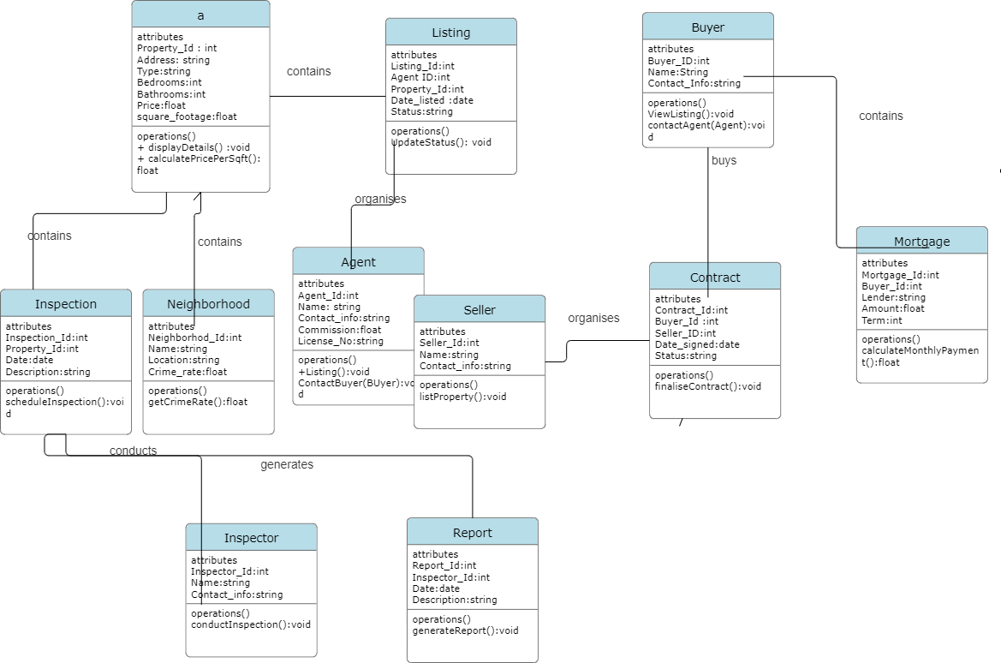

**Project Report: Real Estate Management System**

**1. Introduction:** The Real Estate Management System (REMS) is a digital platform designed to streamline processes, enhance efficiency, and promote transparency in the management of real estate assets. This report provides an overview of the REMS project, including its objectives, functionalities, implementation details, and challenges faced during development.

**2. Objectives:** The primary objectives of the REMS project are:

* To create a comprehensive platform for managing real estate properties, agents, buyers, and sellers.
* To automate routine tasks and improve operational efficiency.
* To provide stakeholders with real-time access to property information and transaction details.
* To enhance the overall management and decision-making processes in the real estate industry.

**3. Functionalities:** The REMS platform offers the following key functionalities:

* Property Management: Allows users to add, update, view, and delete property information, including attributes such as address, type, price, and square footage.
* Agent Management: Enables the management of agent details, including name, contact information, commission percentage, and license number.
* Buyer and Seller Management: Supports the management of buyer and seller information, including name and contact details.
* Listing Management: Facilitates the creation and management of property listings, including the agent responsible, date listed, and status.
* Contract and Mortgage Management: Allows users to create and manage contracts documenting agreements between buyers and sellers, as well as record mortgage details.
* Inspection and Neighborhood Management: Supports the tracking of property inspections and management of neighborhood information, including crime rate statistics.
* Report Generation: Generates reports summarizing inspection findings and other relevant information.

**4. Implementation Details:** The REMS project was implemented using a relational database management system (RDBMS) for data storage and management. The database schema was designed based on the entity-relationship (ER) diagram provided in the project requirements. SQL queries were used to create tables in the database and establish relationships between them.

The project was developed using Java programming language for the backend logic and user interface. Java Database Connectivity (JDBC) was used to interact with the database and perform CRUD (Create, Read, Update, Delete) operations. Object-oriented programming principles were followed to design and implement classes representing entities such as Property, Agent, Buyer, Seller, etc.

The user interface was implemented using Java Swing framework to provide a graphical user interface (GUI) for users to interact with the system. The GUI allows users to input data, view property listings, generate reports, and perform other tasks seamlessly.

**5. Challenges Faced:** During the development of the REMS project, several challenges were encountered, including:

* Understanding normalization and relationships: Designing an effective database schema required a thorough understanding of normalization principles and establishing appropriate relationships between entities.
* Writing complex SQL queries: Writing SQL queries to retrieve and manipulate data from multiple tables posed a challenge, especially when dealing with joins and aggregation functions.
* Using DBMS tools and handling errors: Working with RDBMS tools and handling database errors effectively required careful attention to detail and debugging skills.
* Applying theoretical knowledge practically: Applying theoretical concepts learned in database management courses to real-world projects required practical experimentation and problem-solving skills.

**6. Conclusion:** In conclusion, the Real Estate Management System (REMS) project represents a significant step towards modernizing and streamlining real estate operations. By leveraging advanced technology and innovative features, REMS empowers stakeholders to maximize the value of their real estate assets and navigate the challenges of the market with agility and precision. Despite the challenges faced during development, the REMS project provides a robust solution for managing real estate properties, transactions, and related information effectively.